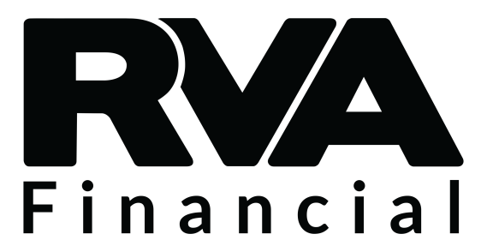
Loan Payoff Authorization

Upon completion, please submit this request by fax to 804-359-4994. Requests will be completed within 72 hours of receipt.

Account Information
Member Number: Click here to enter text.
Loan Number: Click here to enter text.
Best Contact Number: Click here to enter text.

I, Click here to enter text. give authorization for New Generations to provide my
(Member name)
loan payoff information to Click here to enter text..
(Financial Institution)

Member Signature: ________________________________________ Date: 11/10/2017

